Software Development Methods

Parvulescu Valeriu

1231A

Contents:

**1. Business Model-Business Use Case Model, Business Domain Model,Activity Diagrams**

**2. Requirements Analysis Model**

**3.Architecture: Deisgn Class Diagram,Sequence Diagram,Statechart Diagram**

**Part 1:**

**Business Use case model:**

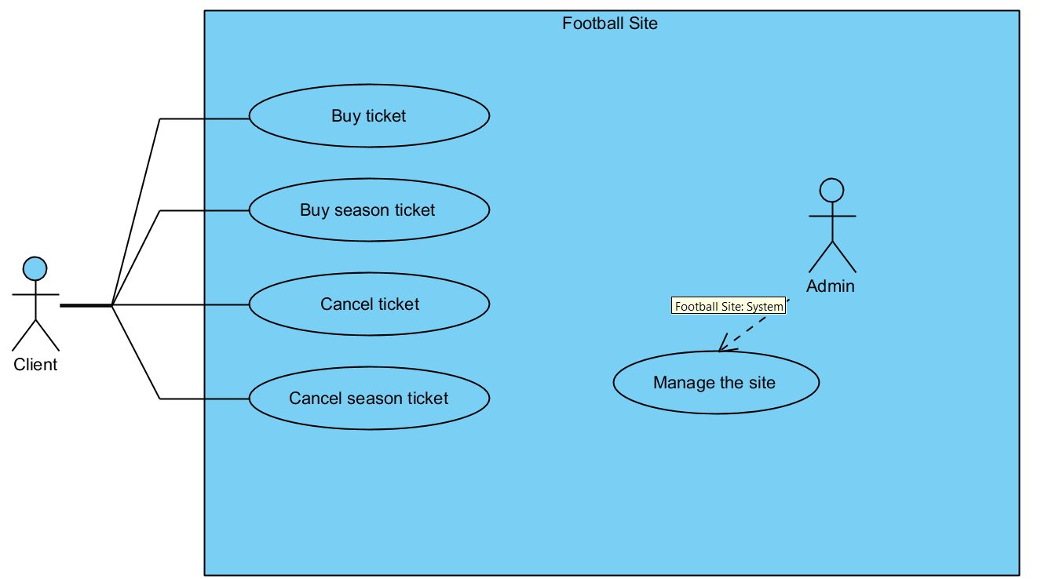

Business Domain model:

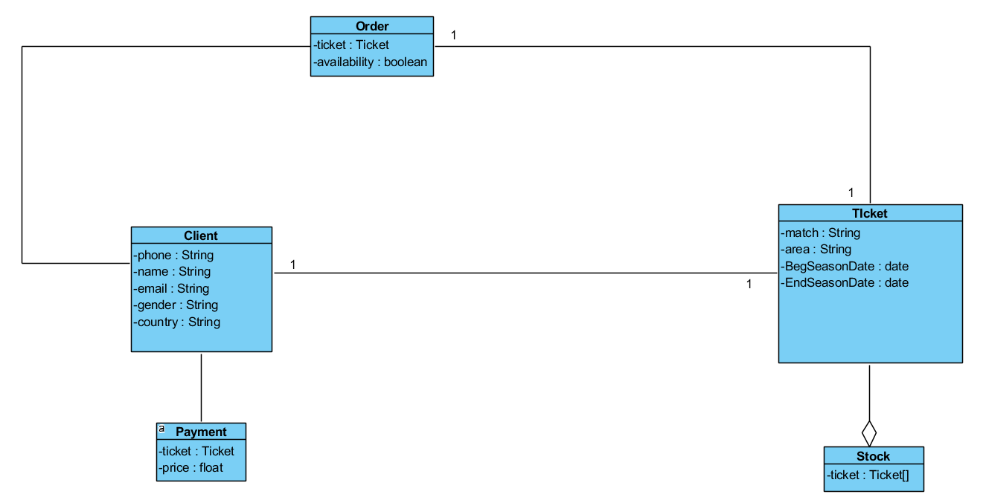

Activity Diagrams:

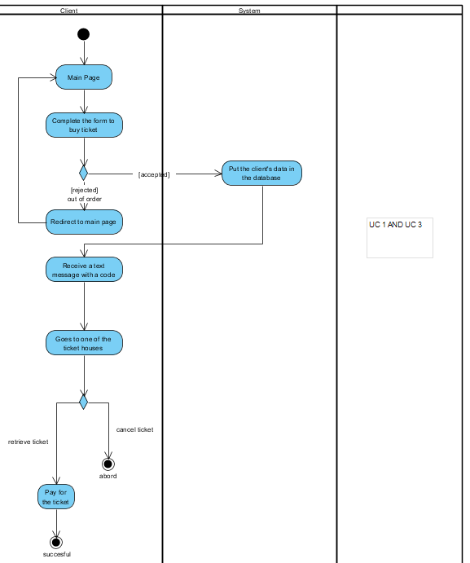

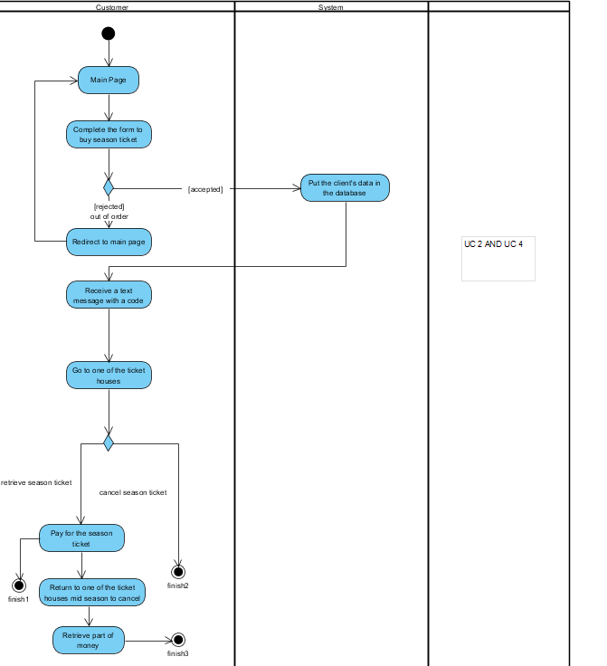

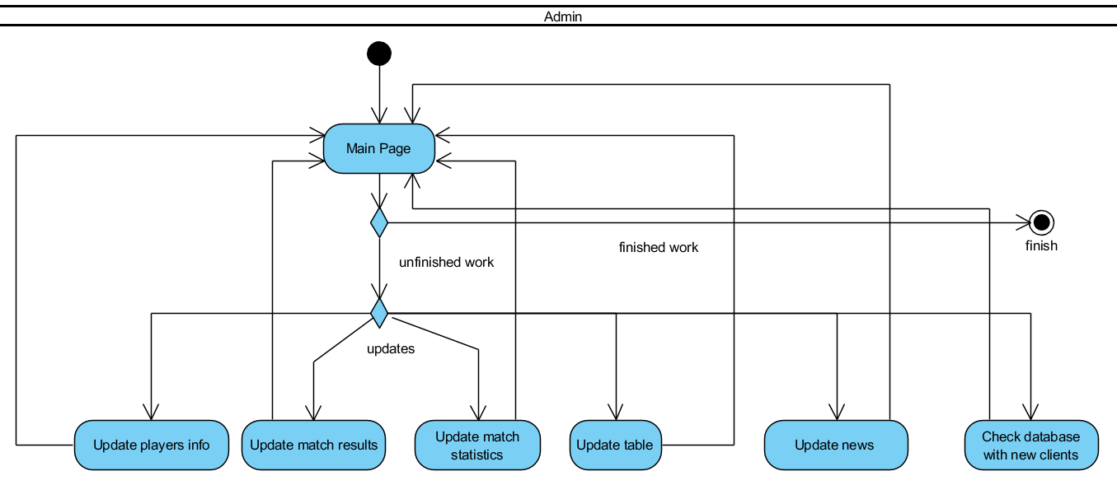

Part 2:

**Requirements:**

System management:

-System receives ticket request from client 8/10

-System gives a response to the client regarding the availability of the ticket 9/10

-In case response is positive,the system sends a text message to the client with an unique code 10/10

-System clears the ticket out of their stock 6/10

Non-Functional Requirements:

Usability:

-training:highschool level

-80% of options can be reached in max 5 steps

Accesibility:

-it is user friendly for all types of people

Performance:

-average function takes 50 miliseconds maximum

Capacity:

-the system provdies 5000 tickets and 1000 season tickets

Reliability:

-Site goes down after 10000 of rapid requests,recovery estimation: 30 seconds-2 minutes

Availability:

-from the beginning of the season until the end of the season for a ticket

-before the beginning of the season for a season ticket

Robustness:

-System validates user input and checks for errors

-System can tackle thousands of fast requests

Manageability:

-The administrators manage the site and all is system and components

Security:

-The user passwords are ecrypted

Scalability:

-stock increasing and new sponsor contract renewals at every 50k users

-using of horizontal scalability: multiple servers for fast requests tackling

**Use case descriptions:**

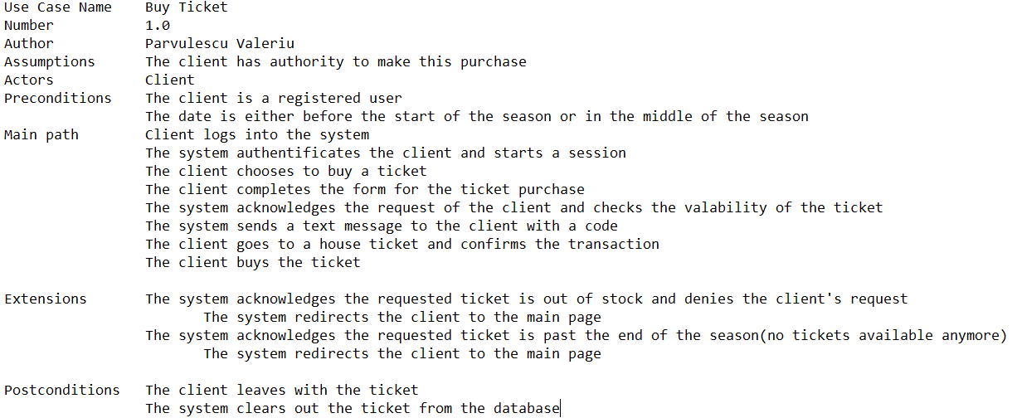

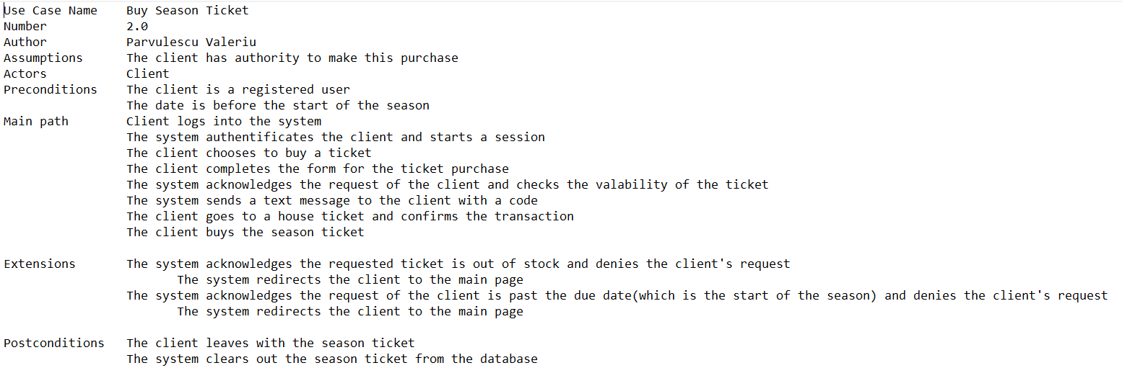

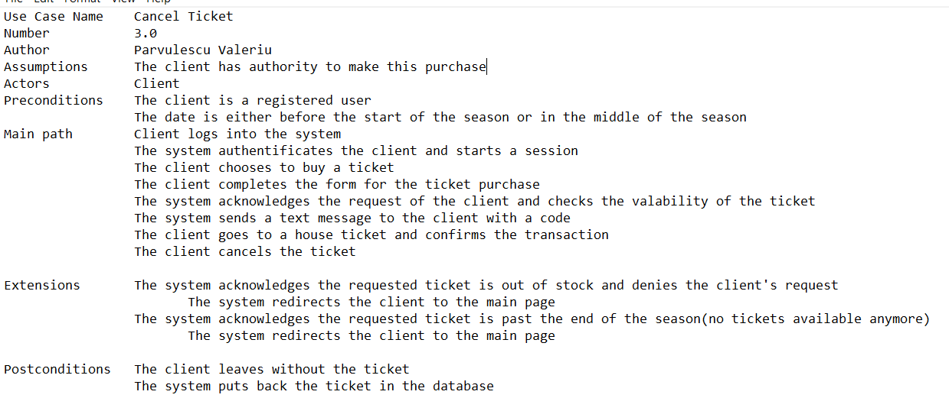

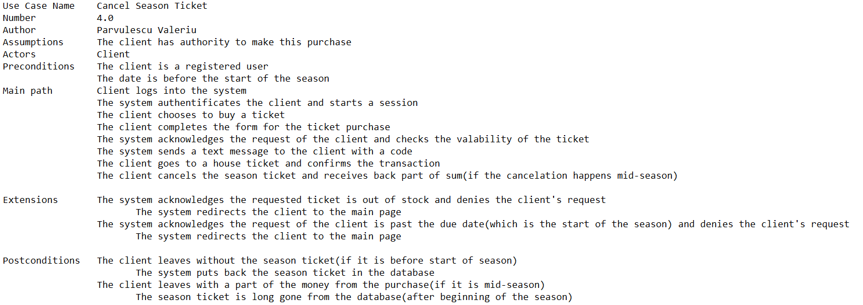

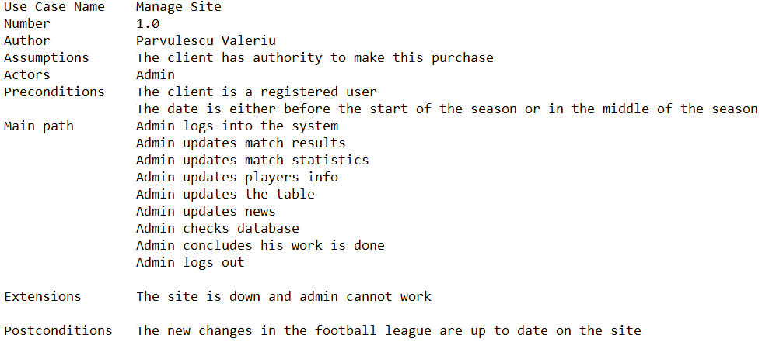

**Operation Contracts**

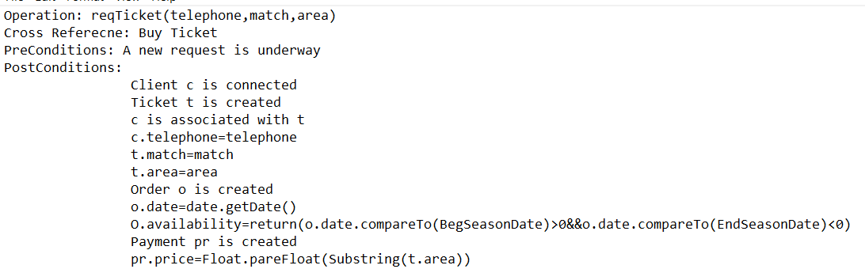

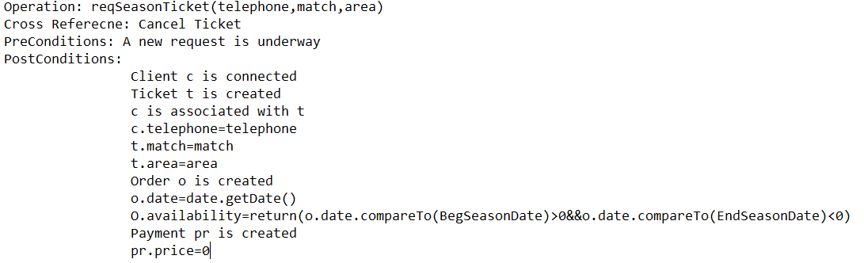

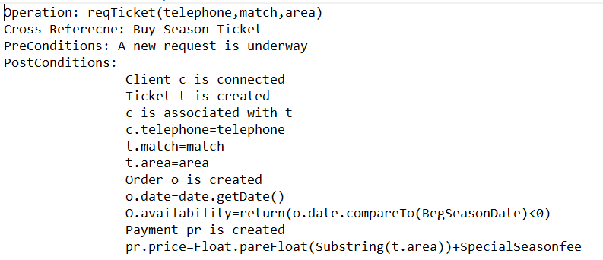

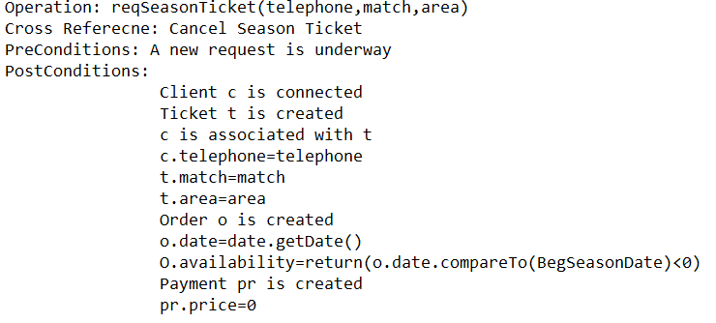

**Software Sequence Diagrams:**

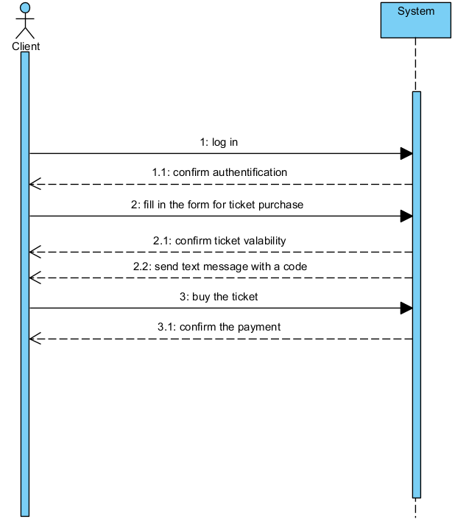

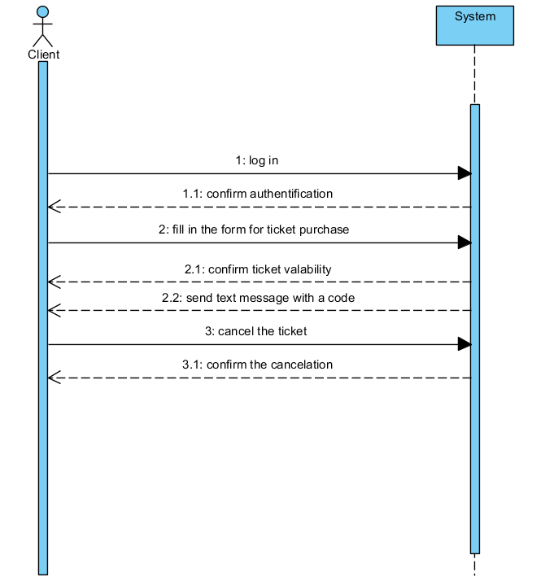

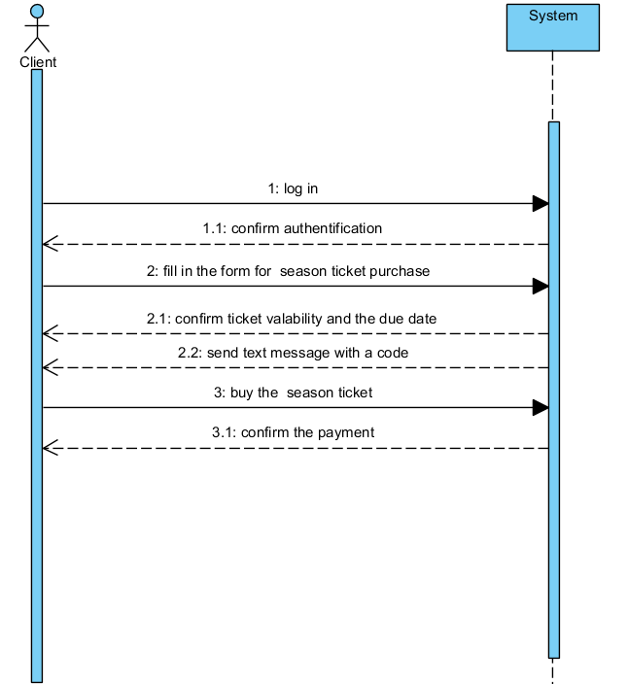

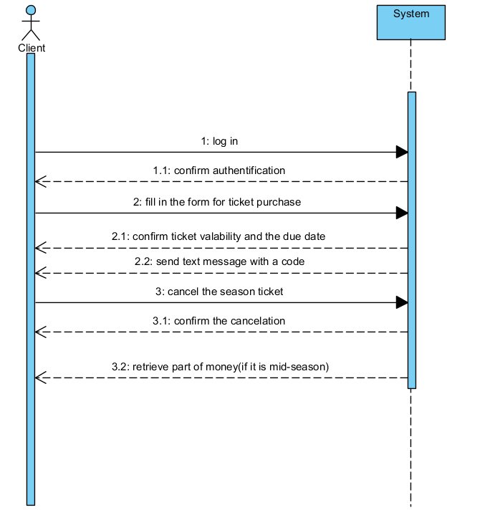

**Part 3:**

**Design Class Diagram:**

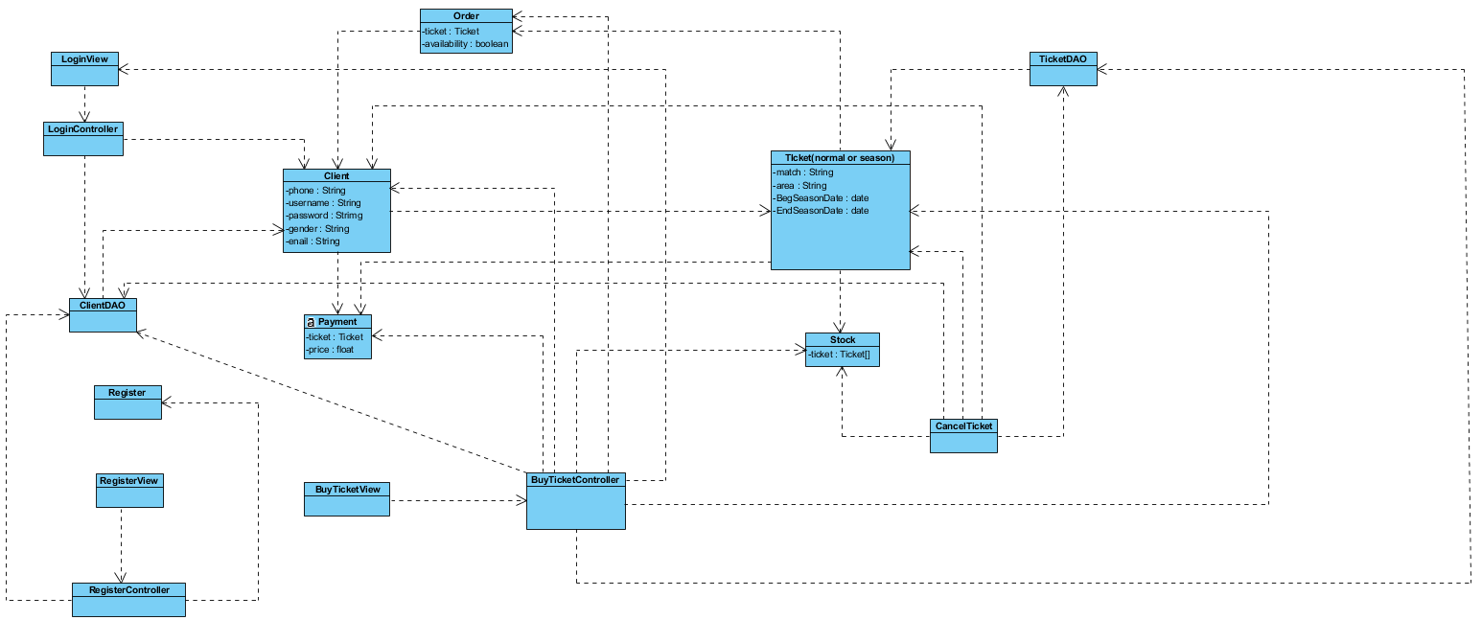

**Sequence Diagram:**

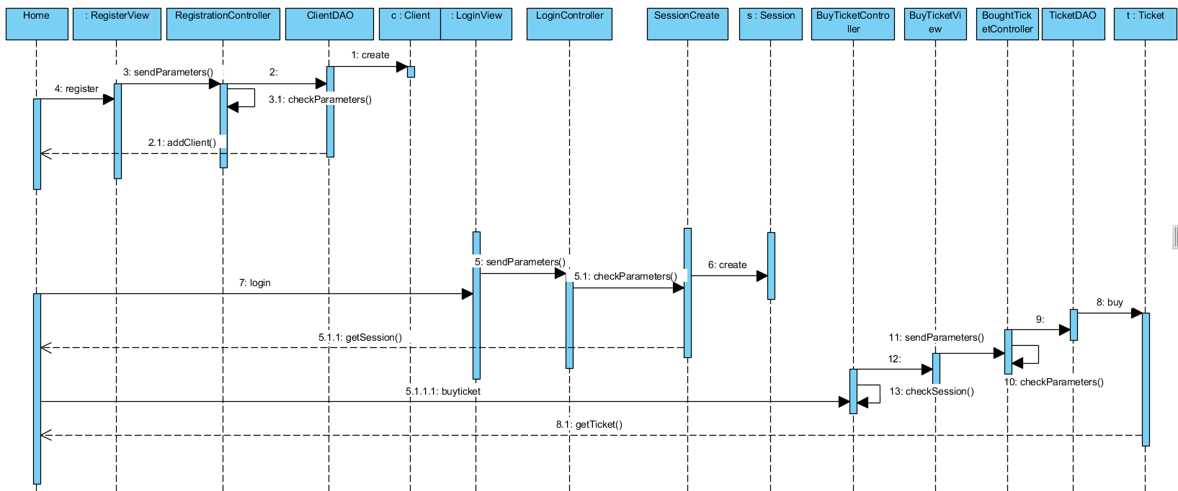

**Statechart Diagrams:**

**Guest**

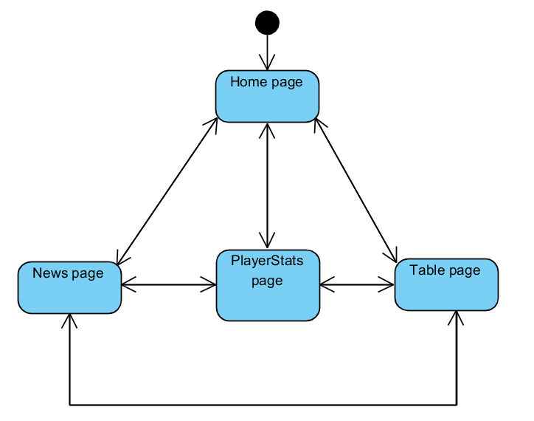

**User:**

